Lab 5 – Configuring SNMP

1. Student No: C18322011 Name: OMAIR DUADU

**See bottom of this page for Instructions.**

1. Topology

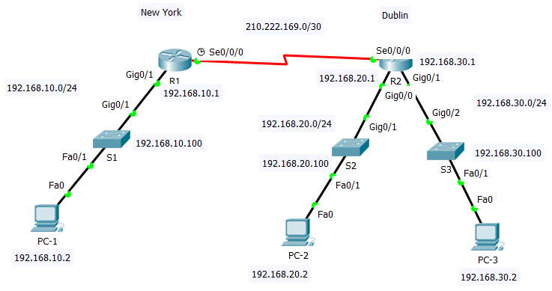

**INSTRUCTIONS**

**Answer the questions marked in Red as you do the Lab**

**Download this Lab doc. Save it with your student number in the filename.**

**Download the Packet Tracer File. Save it with your student number in the filename.**

**Type your answers to the questions into this Lab doc.**

**Put completed Lab doc AND Packet Tracer File in one Zip file.**

**Upload the Zip to Bright Space at end of Lab today.**

1. Addressing Table

|  |  |  |  |  |
| --- | --- | --- | --- | --- |
| Device | Interface | IP Address | Subnet Mask | Default Gateway |
| R1 | G0/1 | 192.168.10.1 | 255.255.255.0 | N/A |
|  | S0/0/0 (DCE) | 210.222.169.1 | 255.255.255.252 | N/A |
| R2 | G0/0 | 192.168.20.1 | 255.255.255.0 | N/A |
|  | G0/1 | 192.168.30.1 | 255.255.255.0 | N/A |
|  | S0/0/0 | 210.222.169.2 | 255.255.255.252 | N/A |
| S1 | VLAN 1 | 192.168.10.100 | 255.255.255.0 | 192.168.10.1 |
| S2 | VLAN 1 | 192.168.20.100 | 255.255.255.0 | 192.168.20.1 |
| S3 | VLAN 1 | 192.168.30.100 | 255.255.255.0 | 192.168.30.1 |
| PC-1 | NIC | 192.168.10.2 | 255.255.255.0 | 192.168.10.1 |
| PC-2 | NIC | 192.168.20.2 | 255.255.255.0 | 192.168.20.1 |
| PC-3 | NIC | 192.168.30.2 | 255.255.255.0 | 192.168.30.1 |

1. Objectives

Part 1: Set Up the Topology shown in the diagram - Already set up.

Part 2: Configure Devices and Verify Connectivity - Use Part-2-Base-configs.txt file

* Configure basic settings on PCs, and routers.
* Configure ip address and subnet mask on S1, S2 and S3 SVIs
* Configure EIGRP routing on R1, and R2.

Part 3: Configure SNMP and check network device status

* Configure SNMP on R1, R2, S1, S2, and S3.
* Check status of MIB variables

Part 4: Get and Set network device parameters

* Use MIB Bowser to examine device settings and GET/SET device parameters SNMP on R1, R2, S1, S2, and S3.

1. Background / Scenario

Simple Network Management Protocol (SNMP) is a network management protocol which can be used to monitor and control clients on a network. SNMP can be used to **get** and **set** variables indicating the status and configuration of network hosts such routers and switches, and also network client computers.

In this lab you will configure routers and switches as SNMP agents. You will use the **MIB browser** on one of the PCs to get information about the configuration of the routers and the switches. You will also set some configuration parameters.

SNMP Operation

SNMP allows administrators to manage and monitor devices on an IP network. The SNMP Elements are SNMP Manager (Software), SNMP Agent (Nodes), MIB (Management Information Base). SNMP Operations are **Trap** (Send info) **Get** (Collect info), **Set** (Change configuration).

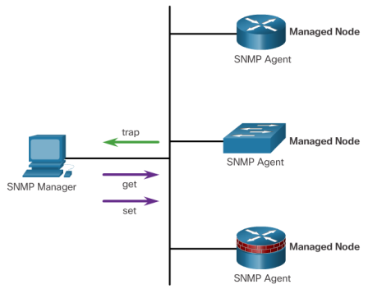

The MIB (Management Information Base)

Information about the status of network devices is stored in variables in a Management Information Base (**MIB**) on each device. The Management software uses these variables to monitor and control network devices. The variables are organized hierarchically.

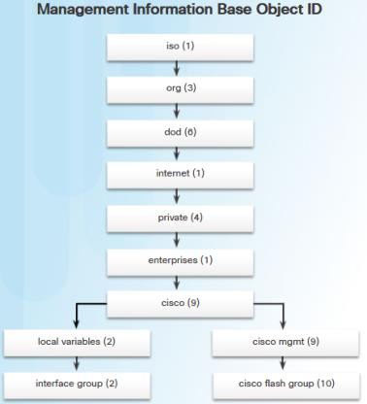The MIB defines each variable as an object ID (OID). OIDs uniquely identify managed objects in the MIB hierarchy. The MIB organizes the OIDs based on RFC standards into a hierarchy of OIDs, usually shown as a tree. See diagram.

OIDs can be described in words (iso.org.dod.internet.mgmt.mib-2.system.sysUpTime) and numbers (0.1.3.6.1.2.1.1.3.0) to find a variable in the tree.

OID = 0.1.3.6.1.2.1.1.3 describes the variable **sysUpTime**

You will use the MIB browser on the Packet Tracer PCs to read the MIB on the network devices to get information about the status of a device.

Required Packet Tracer Resources

* 2 Routers (Cisco 1941 with Cisco IOS Release 15.2(4)M3 universal image or comparable)
* 3 Switches (Cisco 2960 with Cisco IOS Release 15.0(2) lanbasek9 image or comparable)
* 3 PCs (Packet Tracer End Devices)

1. Set Up the Topology
   1. Cable the network as shown in the topology. - Already set up
2. Configure Devices and Verify Connectivity

In Part 2, you will configure basic settings on the routers and PCs. Refer to the Topology and Addressing Table for device names and address information. You have been provided with the basic device settings in the Part-2-Base-configs.txt file. Paste in the configs for Steps 1 to 4 from this file to config the basic settings.

* 1. Configure IP addresses on PC-1, PC-2 and PC-3.
  2. Configure basic settings on R1.
     1. Disable DNS lookup, i.e. configure **no ip domain-lookup.**
     2. Configure the device name as shown in the topology.
     3. Configure interface IP addresses as shown in the Topology and Addressing Table.
     4. Assign a clock rate of **64000** to the S0/0/0 interface.
     5. .Configure **logging synchronous** for the console line.
  3. Configure basic settings on R2.
     1. Configure the device name as shown in the topology.
     2. Configure interface IP addresses as shown in the Topology and Addressing Table.
     3. Disable DNS lookup.
     4. Configure **logging synchronous** for console line.
  4. Configure basic settings on S1, S2, and S3
     1. Configure the device name as shown in the topology.
     2. Configure interface VLAN 1 IP addresses as shown in the Topology and Addressing Table.
     3. Disable DNS lookup.
     4. Configure **logging synchronous** on the console line.
  5. Configure OSPF routing on R1 and R2.
     1. Assign 1 as the OSPF process ID and advertise all networks on R1 and R2. The OSPF configuration for R1 is included for reference.

You must work out the OSPF configs for R2 yourself.

R1(config)# **router ospf 1**

R1(config-router)# **network 192.168.10.0 0.0.0.255 area 0**

R1(config-router)# **network 210.222.169.0 0.0.0.3 area 0**

R1(config-router)# **end**

* + 1. After configuring OSPF on R1 and R2, verify that all routers have complete routing tables listing all networks in the topology. (Use **show ip route**).

What networks can you see in R1 and R2 routing tables? List them below in this format: x.x.x.x/x, e.g. 192.168.10.0/24.

R1__________________________________________________________________

192.168.10.0/24

192.168.20.0/24

192.168.30.0/24

210.222.169.0/24

R2__________________________________________________________________

192.168.10.0/24

192.168.20.0/24

192.168.30.0/24

210.222.169.0/24

Are all the networks in the topology in R1 **and** R2 routing tables? YES

Troubleshoot if this is not the case.

* 1. Verify connectivity between devices.

**Note:** It is very important to verify connectivity **before** you do Part 3. You will need to be able to access the devices on the 192.168.20.0/24 and 192.168.20.0/24 networks to check device status using SNMP.

* + 1. From PC-1, ping PC-2 and PC-3.

Were your pings successful? YES

* + 1. From PC-1, ping S1, S2, and S3

Were your pings successful? YES

1. Configure SNMP and Check Network Device Status

Routers and switches can be set up as SNMP agents in Packet Tracer. We can then read the status of these devices using the MIB browser on the Packet Tracer PCs.

* 1. Configure SNMP on the Routers and Switches
     1. Configure SNMP on routers R1, R2, and switchers S1, S2, and S3. The SNMP configuration for R1 is included for reference. **It is the same config on all routers and switches**. Note that **classro** and **classrw** are known as *community strings* in SNMP. Community strings are plaintext passwords! You will use **classro** and **classrw** to login to each device using the MIB Browser.

R1(config)# **snmp-server community classro ro**

R1(config)# **snmp-server community classrw rw**

R1(config)# **end**

* 1. 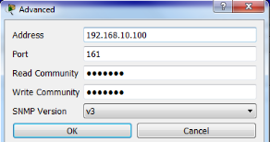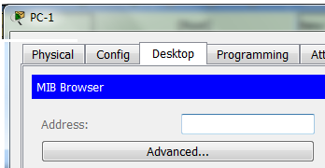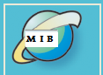Use MIB Browser to check device status.

Open the **MIB** Browser from PC-1 Desktop.

Click the **Advanced** **button**

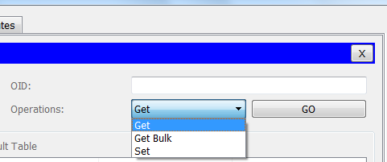Enter the IP address of Switch S1 and the read and write community strings **classro** and **classrw.**Click Ok

Drag Left/RightHere

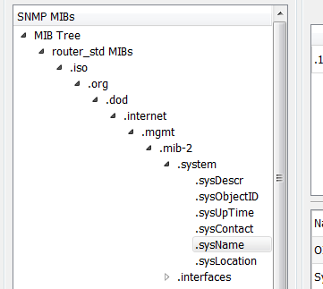Select **Get** fromOperations Drop Down menu

Expand the MIB Tree until you see the system  
variables. Drag the Tree Window as shown to   
left or right to see more of the MIB Tree.

Click on **sysName.** Notice how the OID changes.

Click **Go.** Name of the switch (S1) is retrieved from device MIB.  
(If name does not appear, click Go again).

* 1. 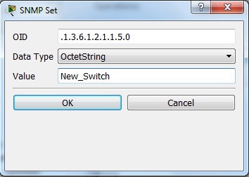Use MIB Browser to change device settings

Leave **sysName** selected in the MIB Tree.

Select **Set** fromOperations Drop Down menu.

Select OctetString from Data Type drop-down Menu.

Enter new name for Switch S1. Hit Ok.

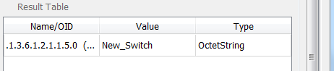Click **Go**. Name of S1 changes to new name.

Go to switch S1 in the topology.   
Has S1’s name changed at the command   
prompt? Yes

1. Get and Set Network Device parameters

Use the MIB Browser on PC-1 to answer the following questions about the network devices and do the Task below for each device.

**Q1** What version of IOS software is running on each router and switch? (Just write the version number).

R1 15.1, R2 15.1, S1 12.2, S2 12.2, S3 12.2

**Q2** What is the up time of each router and switch?

R1 1 hours 18 minutes 5 seconds,

R2 1 hours 18 minutes 19 seconds,

S1 1 hours 14 minutes 54 seconds,

S2 1 hours 15 minutes 7 seconds ,

S3 1 hours 14 minutes 31 seconds

**Q3** What is the operational status of each interface on each router?

R1 Vlan1 down,

G0/0 up,

G0/1 up,

S0/0/0 up,

S0/0/1 down

R2 Vlan1 down,

G0/0 up,

G0/1 up,

S0/0/0 up,

S0/0/1 down

**Q4** What IP Route Destination Networks are in the Routing Tables on R1 and R2?

R1

192.168.30.1,

210.222.169.0,

210.222.169.2

192.168.10.0,

192.168.20.0,

192.168.20.1,

192.168.30.0,

R2

210.222.169.0,

210.222.169.1

192.168.10.0,

192.168.10.1,

192.168.20.0,

192.168.30.0,

Do the Destination Networks match the networks you listed in Part 2, Step 5b above? YES

**TASK:** Change the name of each router and switch to a name of your choice.

Check the device at the CLI. Device name should now have new name.

1. Router Interface Summary Table

|  |  |  |  |  |
| --- | --- | --- | --- | --- |
| Router Interface Summary | | | | |
| Router Model | Ethernet Interface #1 | Ethernet Interface #2 | Serial Interface #1 | Serial Interface #2 |
| 1800 | Fast Ethernet 0/0 (F0/0) | Fast Ethernet 0/1 (F0/1) | Serial 0/0/0 (S0/0/0) | Serial 0/0/1 (S0/0/1) |
| 1900 | Gigabit Ethernet 0/0 (G0/0) | Gigabit Ethernet 0/1 (G0/1) | Serial 0/0/0 (S0/0/0) | Serial 0/0/1 (S0/0/1) |
| 2801 | Fast Ethernet 0/0 (F0/0) | Fast Ethernet 0/1 (F0/1) | Serial 0/1/0 (S0/1/0) | Serial 0/1/1 (S0/1/1) |
| 2811 | Fast Ethernet 0/0 (F0/0) | Fast Ethernet 0/1 (F0/1) | Serial 0/0/0 (S0/0/0) | Serial 0/0/1 (S0/0/1) |
| 2900 | Gigabit Ethernet 0/0 (G0/0) | Gigabit Ethernet 0/1 (G0/1) | Serial 0/0/0 (S0/0/0) | Serial 0/0/1 (S0/0/1) |
| **Note**: To find out how the router is configured, look at the interfaces to identify the type of router and how many interfaces the router has. There is no way to effectively list all the combinations of configurations for each router class. This table includes identifiers for the possible combinations of Ethernet and Serial interfaces in the device. The table does not include any other type of interface, even though a specific router may contain one. An example of this might be an ISDN BRI interface. The string in parenthesis is the legal abbreviation that can be used in Cisco IOS commands to represent the interface. | | | | |